GLOBE EDITORIAL

How to help Massachusetts retailers
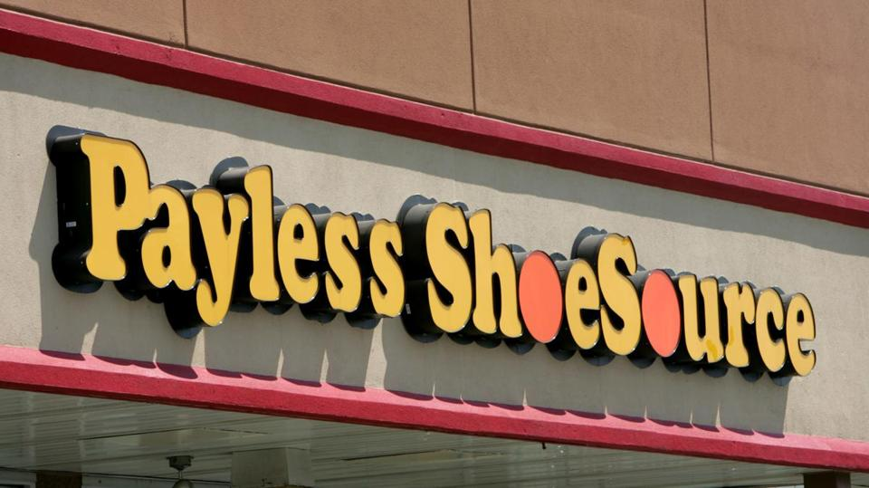
MATT ROURKE/AP PHOTO
Payless ShoeSource filed for Chapter 11 bankruptcy protection, becoming the latest retailer to succumb to increasing competition from online rivals. The retailer announced earlier this month that it would be immediately closing nearly 400 stores.

APRIL 22, 2017

RETAIL STORES HAVE taken a real hit in the last several years. Just last month, the national retail sector shed 30,000 jobs. Last year, the retail sector job loss was almost 90,000.
That shouldn’t come as a surprise. After all, hardly a month goes by without news of another retail chain closing stores — Payless ShoeSource, Bebe, and Rue 21, among many other suffering retailers, all announced plans to close stores this month. But it should be a real concern, for two reasons. First, many retail-sales jobs don’t require college degrees, and thus offer a way up the career ladder toward a decent, though hardly highly paid, living for workers who didn’t attend college. Second, smaller retail businesses keep local downtowns lively, interesting, and convenient; their owners are often participants in local civic affairs and contributors to local causes.
That argues for a stronger state effort to help out where possible. One area is on the sales tax front, where brick-and-mortar retailers, who must collect the state’s 6.25 percent sales tax, compete with out-of-state Internet vendors whose goods are sold tax free.
The best way to address that disparity would be through congressional action. As matters currently stand, a state can apply its sales tax only if a business has a physical nexus or presence — usually taken to mean an actual facility — in that state. In a Congress controlled by a tax-averse Republican Party, changing that may take some doing. Still, as more and more sales migrate from brick-and-mortar stores to big, out-of-state (and thus tax-free) Internet retailers, the issue should become more of a bipartisan concern.

Meanwhile, the state Department of Revenue recently took some innovative action, instructing out-of-state vendors with Massachusetts sales of more than $500,000 annually to start collecting this state’s sales taxes on orders from Massachusetts. The Baker administration is trying to stretch the definition of what a sales-tax-qualifying nexus is, asserting that things like purchase-facilitating apps or software on customers’ smart phones and laptops, or even digital “cookies,” qualify as a sufficient presence. That will obviously trigger a legal challenge, which will take time to wend its way through the court system. Still, it’s well worth the effort, particularly if the ultimate result is a judicial broadening of the circumstances in which a state can tax out-of-state Internet sales.
And here’s something Beacon Hill policy makers could do that would help local retailers in the shorter term: Restore the summer sales tax holiday. Most years since 2004, Massachusetts has designated a summer weekend as one in which the sales tax doesn’t apply. That gives retailers an event to plan and advertise around.
“For some of our retailers, like a small mom-and-pop furniture store, that weekend can account for 10 percent of their annual sales,” says Jon Hurt, president of the Retailers Association of Massachusetts. “It gives us two tax-free days to try to attract back some of hundreds of millions of dollars that otherwise go to a business on the other end of a smart phone.”
Given the value of brick-and-mortar retailers, and the tough odds they face in today’s digital economy, authorizing an annual summer sales tax holiday should be a Beacon Hill priority.

